**EXP NO: 13**

**Aim:** To Create a Virtual Hard Disk and allocate the storage using VM ware Workstation.

**Implementation:**

1.install and setup VM ware software and create a new virtual machine

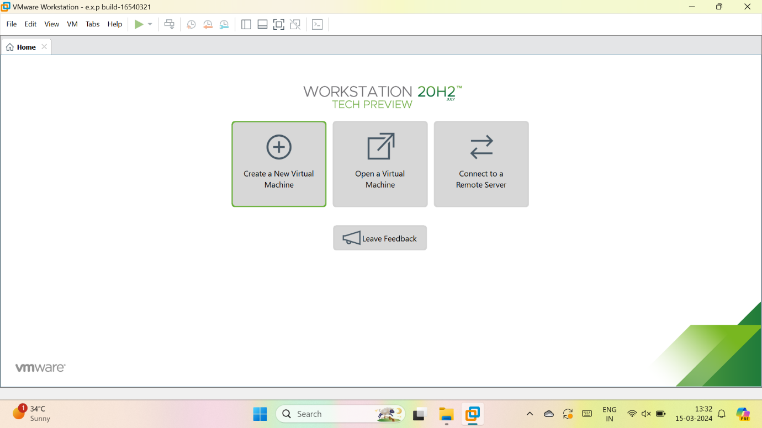

2.select typical

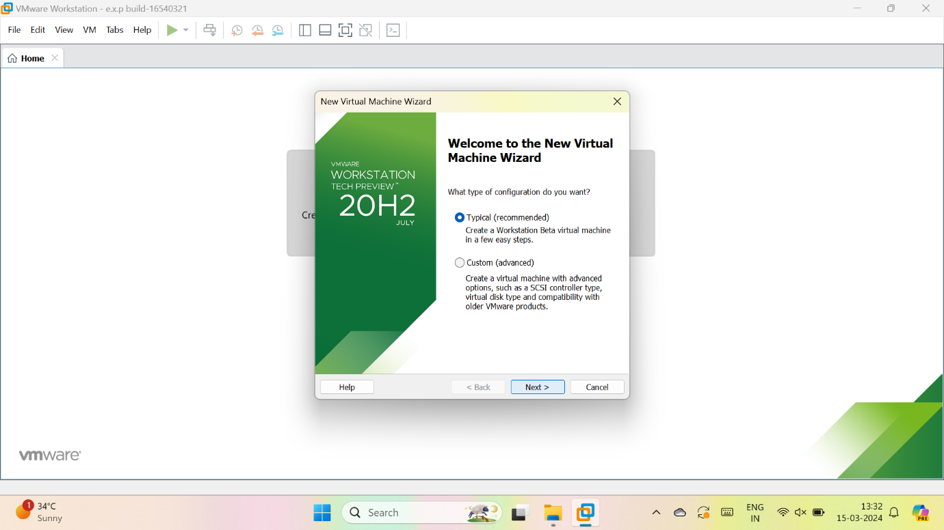

3.we have to select, I will install the OS later

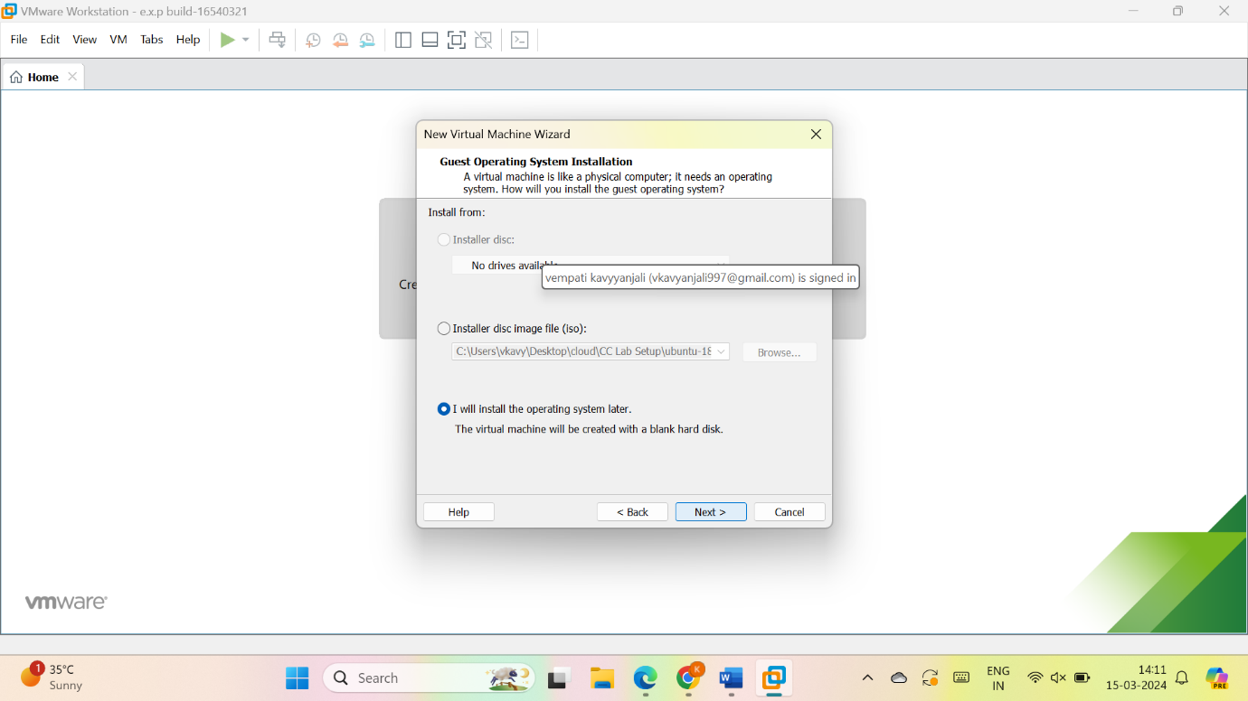

4.give name for VM

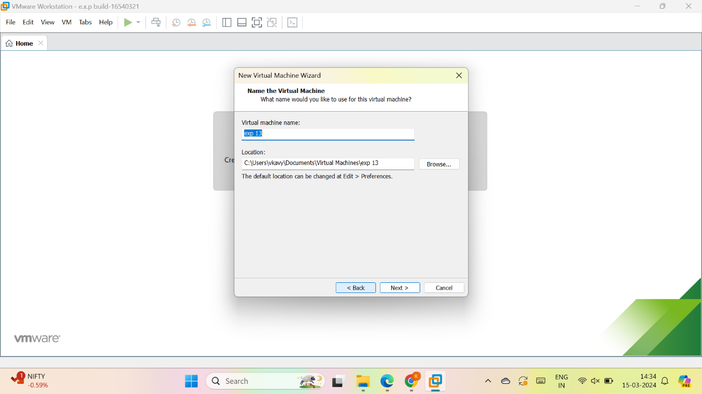

5.give the maximum size of disk as 15GB and select, store virtual disk as a single file and give next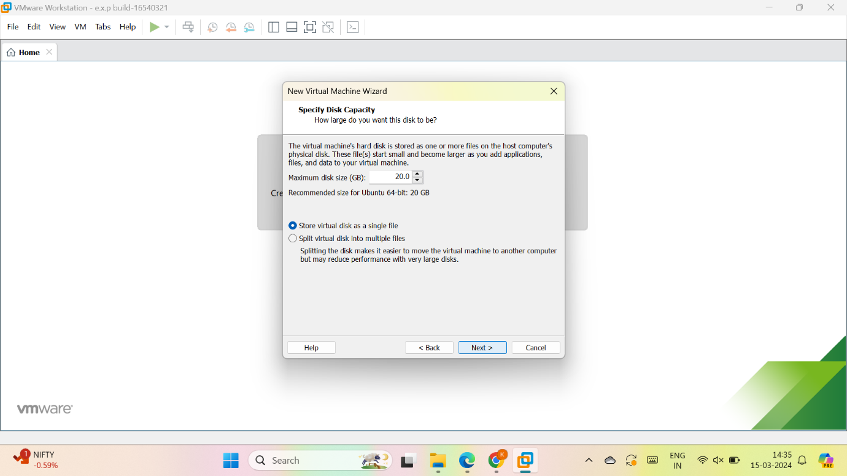

6.check the description

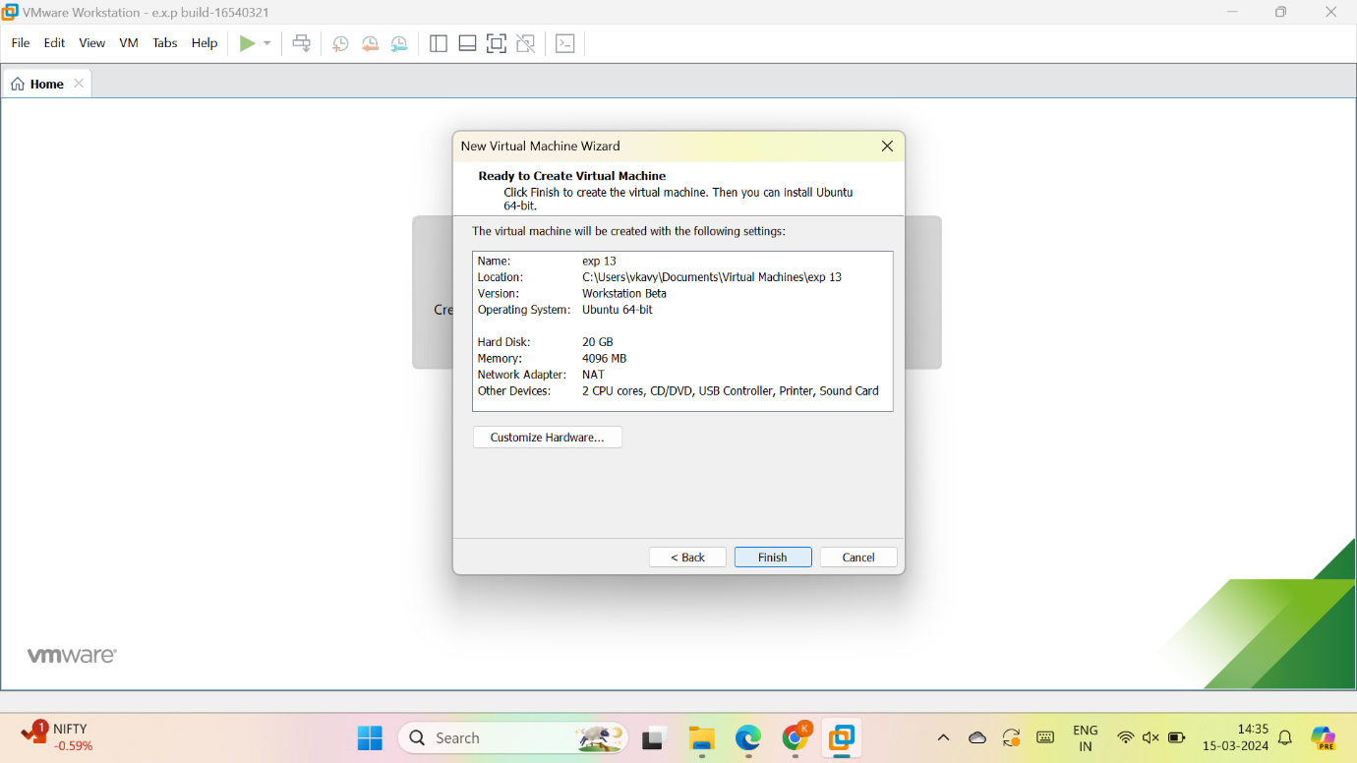

7.vm is created

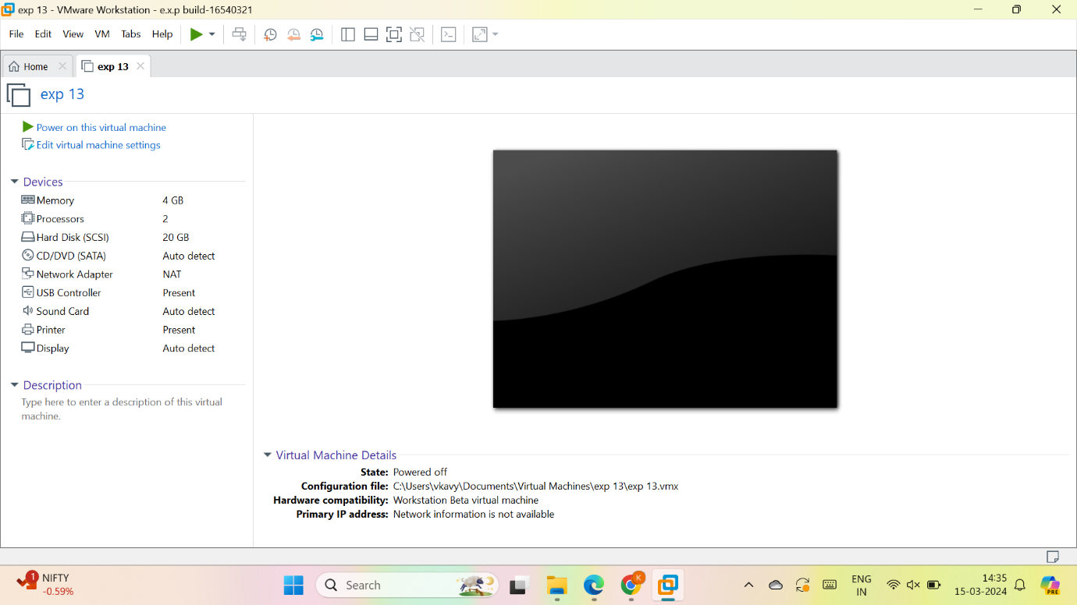

8. As per given question we have to modify the description of VM : Virtual Hard Disk and allocate the storage

Select hard disk and go to add

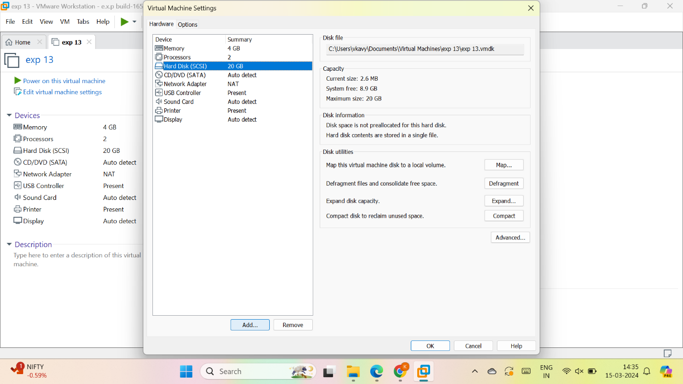

Select hard disk

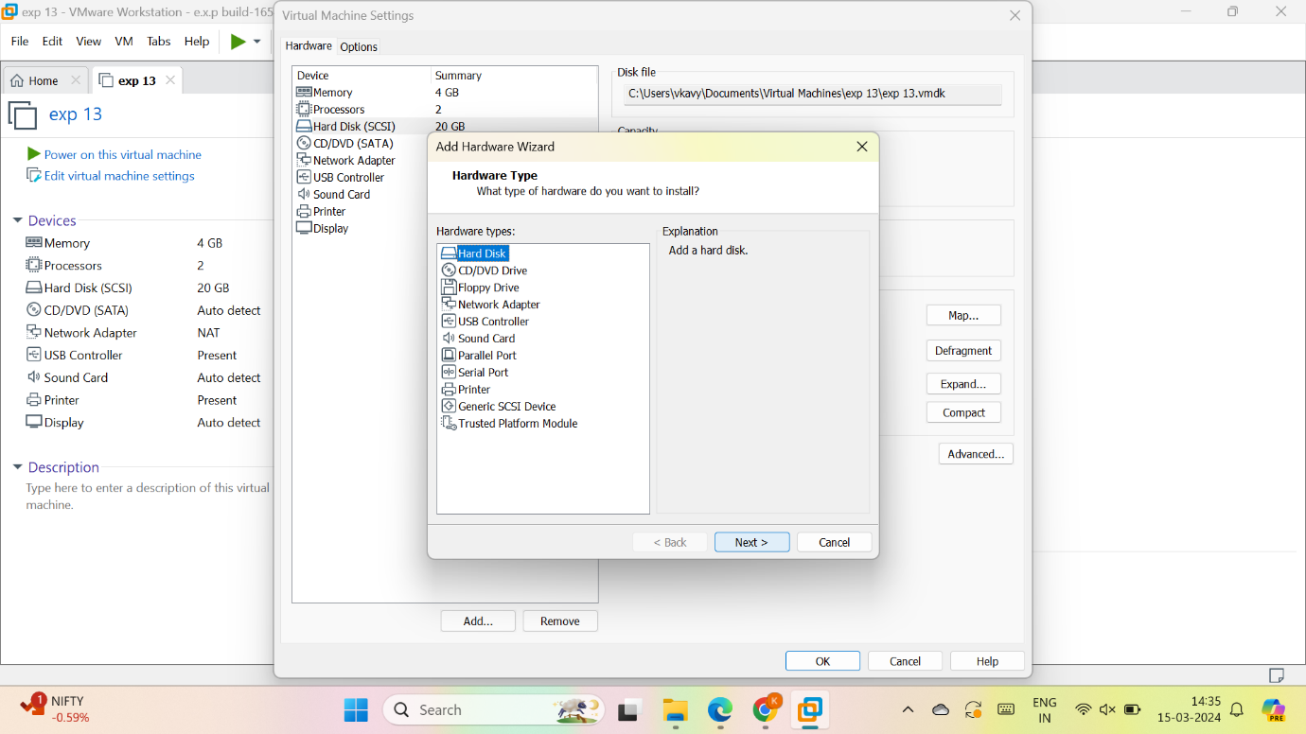

Select type

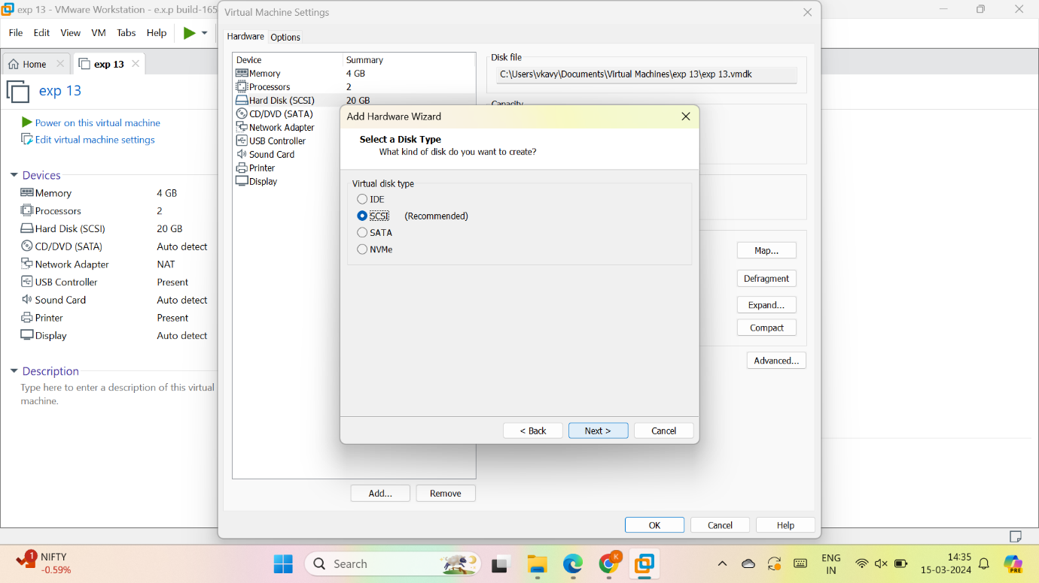

Go through following steps

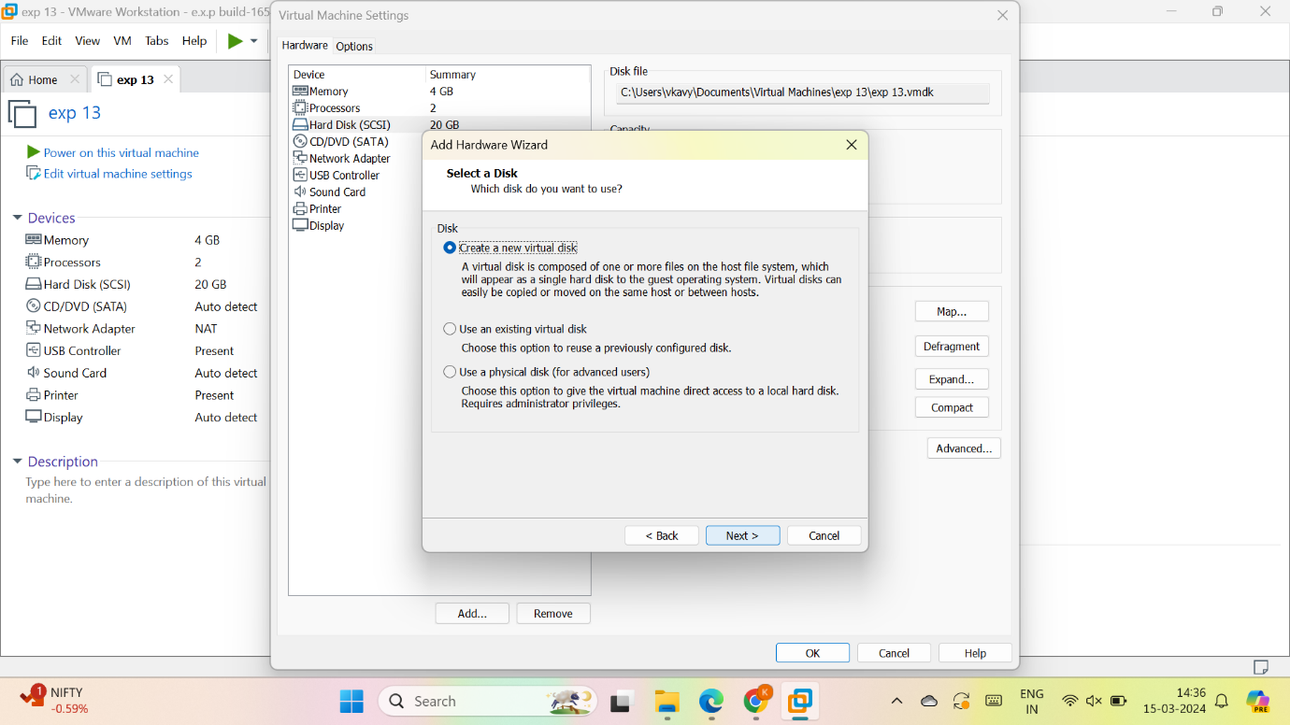

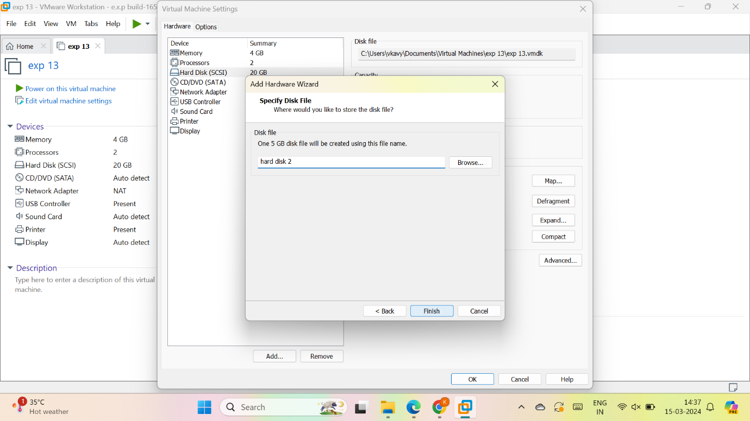

10.now the VM is created as per given data with 2 hard disk

